# Viral-Tag (Pintrest RSS Feed Reader)

## Prerequisite :

### Node JS Server

## Technology Used :

### Angular Js

### Node Js

### Twitter Bootstrap

### HTML 5

### CSS 3

## Module Used

### Node Express

### Bluebird Promise

### Rest-Client

### Angular-Moment

### Moment Js

### Body-Parser

### Path

## Public API Used

### http://cloud.feedly.com/v3/streams/contents?streamId=feed/url /feed.rss

## Note: - You might need to change the address required in application.js for the following files.

* RSSFEED.js

## Back-End Design :

### POST RSS FEED

|  |  |
| --- | --- |
| Method | Post |
| URL | http://localhost:8080/newFeed |
| Req | {  "url":"http://cloud.feedly.com/v3/streams/contents?streamId=feed/https://in.pinterest.com/abhhisheksharma/feed.rss",  "title":"PintrestFeeds"  } |
| Res | success |
|  |  |

## 

### GET RSS FEED

|  |  |
| --- | --- |
| Method | GET |
| URL | http://localhost:8080/newFeed |
| Req |  |
| Res | [  {  "url": "http://cloud.feedly.com/v3/streams/contents?streamId=feed/https://www.pinterest.com/azero0/feed.rss",  "title": "Popular Feeds"  },  {  "title": "Abhishek Feed",  "url": "http://cloud.feedly.com/v3/streams/contents?streamId=feed/https://in.pinterest.com/abhhisheksharma/feed.rss"  }  ] |

## 

### Update RSS FEED

|  |  |
| --- | --- |
| Method | PUT |
| URL | http://localhost:8080/newFeed |
| Req | {  "url":"http://cloud.feedly.com/v3/streams/contents?streamId=feed/https://in.pinterest.com/abhhisheksharma/feed.rss",  "title":"PintrestFeeds"  } |
| Res | {  "url": "PintrestFeeds",  "response": {  "id": "feed/https://in.pinterest.com/abhhisheksharma/feed.rss",  "direction": "ltr",  "updated": 1458139197269,  "title": "The KingSlayer !!!!",  "alternate": [  {  "href": "https://www.pinterest.com/abhhisheksharma/",  "type": "text/html"  }  ],  "items": [  {  "id": "6bs93LmA9jCoJZaw5iCc+uiIsIVxzi60AwWxk4iGBqs=_1537fde6f55:5981ee2:70e34146",  "originId": "https://www.pinterest.com/pin/419116309054338434/",  "fingerprint": "ec9319c8",  "title": "Ellie_Goulding_-_Bur",  "published": 1458128833000,  "crawled": 1458139197269,  "alternate": [  {  "href": "https://www.pinterest.com/pin/419116309054338434/",  "type": "text/html"  }  ],  "summary": {  "content": "<p><a href=\"https://www.pinterest.com/pin/419116309054338434/\"><img src=\"https://s-media-cache-ak0.pinimg.com/236x/1a/5a/57/1a5a57ef96c7132fe877106ac567ebbb.jpg\"></a></p><p>Ellie_Goulding_-_Burn</p>",  "direction": "ltr"  },  "origin": {  "streamId": "feed/https://in.pinterest.com/abhhisheksharma/feed.rss",  "title": "The KingSlayer !!!!",  "htmlUrl": "https://www.pinterest.com/abhhisheksharma/"  },  "unread": true  },  {  "id": "6bs93LmA9jCoJZaw5iCc+uiIsIVxzi60AwWxk4iGBqs=_1537fde6f55:5981ee1:70e34146",  "originId": "https://www.pinterest.com/pin/419116309054338417/",  "fingerprint": "3682ab18",  "title": "fast_and_furious_7_d",  "published": 1458128643000,  "crawled": 1458139197269,  "alternate": [  {  "href": "https://www.pinterest.com/pin/419116309054338417/",  "type": "text/html"  }  ],  "summary": {  "content": "<p><a href=\"https://www.pinterest.com/pin/419116309054338417/\"><img src=\"https://s-media-cache-ak0.pinimg.com/236x/73/83/a3/7383a344d78cecb38776d2115749470f.jpg\"></a></p><p>fast_and_furious_7_deviantart</p>",  "direction": "ltr"  },  "origin": {  "streamId": "feed/https://in.pinterest.com/abhhisheksharma/feed.rss",  "title": "The KingSlayer !!!!",  "htmlUrl": "https://www.pinterest.com/abhhisheksharma/"  },  "unread": true  },  {  "id": "6bs93LmA9jCoJZaw5iCc+uiIsIVxzi60AwWxk4iGBqs=_1528430e170:29abaf7:990654eb",  "originId": "https://www.pinterest.com/pin/419116309053649352/",  "fingerprint": "c5d50084",  "title": "How Smart People Dea",  "published": 1453916742000,  "crawled": 1453916742000,  "alternate": [  {  "href": "https://www.pinterest.com/pin/419116309053649352/",  "type": "text/html"  }  ],  "summary": {  "content": "<p><a href=\"https://www.pinterest.com/pin/419116309053649352/\"><img src=\"https://s-media-cache-ak0.pinimg.com/236x/95/76/d6/9576d623047c942a4c66b4a08a069c00.jpg\"></a></p><p>How Smart People Deal With People They Don’t Like</p>",  "direction": "ltr"  },  "origin": {  "streamId": "feed/https://in.pinterest.com/abhhisheksharma/feed.rss",  "title": "The KingSlayer !!!!",  "htmlUrl": "https://www.pinterest.com/abhhisheksharma/"  },  "unread": true  },  {  "id": "6bs93LmA9jCoJZaw5iCc+uiIsIVxzi60AwWxk4iGBqs=_15282b4ad68:29abaf6:990654eb",  "originId": "https://www.pinterest.com/pin/419116309053646108/",  "fingerprint": "73f0eb9",  "title": "“Humans will all eve",  "published": 1453891825000,  "crawled": 1453891825000,  "alternate": [  {  "href": "https://www.pinterest.com/pin/419116309053646108/",  "type": "text/html"  }  ],  "summary": {  "content": "<p><a href=\"https://www.pinterest.com/pin/419116309053646108/\"><img src=\"https://s-media-cache-ak0.pinimg.com/236x/4f/de/c2/4fdec2784aef76a66f79731fa95e897f.jpg\"></a></p><p>“Humans will all eventually die and never come back to life, so let’s give it our all while we’re alive”</p>",  "direction": "ltr"  },  "origin": {  "streamId": "feed/https://in.pinterest.com/abhhisheksharma/feed.rss",  "title": "The KingSlayer !!!!",  "htmlUrl": "https://www.pinterest.com/abhhisheksharma/"  },  "unread": true  },  {  "id": "6bs93LmA9jCoJZaw5iCc+uiIsIVxzi60AwWxk4iGBqs=_15282b14a38:29abaf5:990654eb",  "originId": "https://www.pinterest.com/pin/419116309053646092/",  "fingerprint": "22239200",  "title": "It was 15th May of 2",  "published": 1453891603000,  "crawled": 1453891603000,  "alternate": [  {  "href": "https://www.pinterest.com/pin/419116309053646092/",  "type": "text/html"  }  ],  "summary": {  "content": "<p><a href=\"https://www.pinterest.com/pin/419116309053646092/\"><img src=\"https://s-media-cache-ak0.pinimg.com/236x/ed/a0/a4/eda0a41c661bb6151aba67a37dd16bcb.jpg\"></a></p><p>It was 15th May of 2013, the clock was about to strike 3:00 pm within 10 mins.My room, room no: 643 was in a horrific condition. The last…</p>",  "direction": "ltr"  },  "origin": {  "streamId": "feed/https://in.pinterest.com/abhhisheksharma/feed.rss",  "title": "The KingSlayer !!!!",  "htmlUrl": "https://www.pinterest.com/abhhisheksharma/"  },  "unread": true  },  {  "id": "6bs93LmA9jCoJZaw5iCc+uiIsIVxzi60AwWxk4iGBqs=_15282b034e0:29abaf4:990654eb",  "originId": "https://www.pinterest.com/pin/419116309053646082/",  "fingerprint": "50567d36",  "title": "Have you read this p",  "published": 1453891532000,  "crawled": 1453891532000,  "alternate": [  {  "href": "https://www.pinterest.com/pin/419116309053646082/",  "type": "text/html"  }  ],  "summary": {  "content": "<p><a href=\"https://www.pinterest.com/pin/419116309053646082/\"><img src=\"https://s-media-cache-ak0.pinimg.com/236x/72/6c/8b/726c8bdf0705ba4eb56e22f16026557c.jpg\"></a></p><p>Have you read this poem when you were young and fresh and you couldn’t even guess the deep meaning of these lines? Have you? I am sure you…</p>",  "direction": "ltr"  },  "origin": {  "streamId": "feed/https://in.pinterest.com/abhhisheksharma/feed.rss",  "title": "The KingSlayer !!!!",  "htmlUrl": "https://www.pinterest.com/abhhisheksharma/"  },  "unread": true  },  {  "id": "6bs93LmA9jCoJZaw5iCc+uiIsIVxzi60AwWxk4iGBqs=_15282ac7fa8:29abaf3:990654eb",  "originId": "https://www.pinterest.com/pin/419116309053646053/",  "fingerprint": "8079dd98",  "title": "Are you entering in",  "published": 1453891289000,  "crawled": 1453891289000,  "alternate": [  {  "href": "https://www.pinterest.com/pin/419116309053646053/",  "type": "text/html"  }  ],  "summary": {  "content": "<p><a href=\"https://www.pinterest.com/pin/419116309053646053/\"><img src=\"https://s-media-cache-ak0.pinimg.com/236x/fc/87/b8/fc87b886a3814c7264db937265dd6f66.jpg\"></a></p><p>Are you entering in an engineering college? You don’t know how you will settle there.</p>",  "direction": "ltr"  },  "origin": {  "streamId": "feed/https://in.pinterest.com/abhhisheksharma/feed.rss",  "title": "The KingSlayer !!!!",  "htmlUrl": "https://www.pinterest.com/abhhisheksharma/"  },  "unread": true  }  ]  }  } |

## DB Design:

There is no use of db. Feeds url are stored in a local variable.

## Front-End Design:

### Html Page: Created using HTML5

### Style: using CSS3

### UI design: Bootstrap

### Front-End Controller: Angular JS ; all functions are indicated in the file itself using comments

## Functionality:

***RSS Feed Reader:***

*Idea is to build a feed reader which allows users to add & read multiple RSS feeds. Build both backend and front end of the application and send us the publicly accessible link back to the project (can be hosted on any service).*



Created a feed reader to add and read multiple RSS feeds.

### Procedure to add an RSS FEED

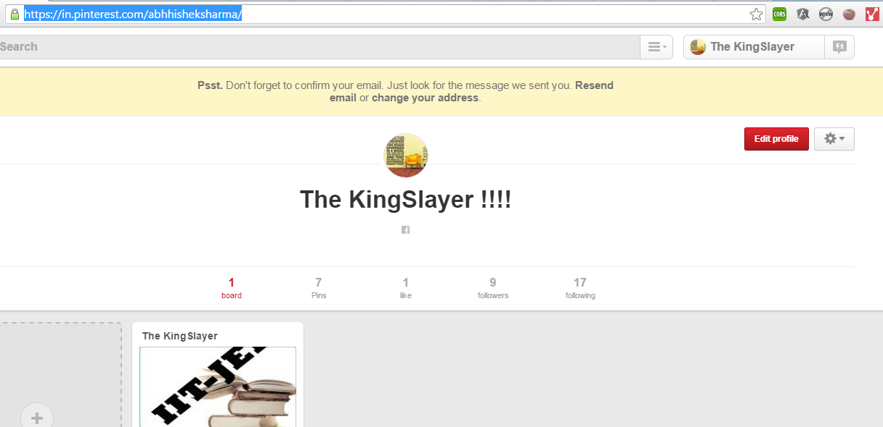

Copy the RSS feed Link

*User can add a feed from a simple popup*



Click on Add a new Feed

Fill the details and submit then close the tab.



See the Feeds in your feed list.

*Once a feed is added, it will be listed under their feeds list. Image and title pulled from the feed will be shown on the UI.*

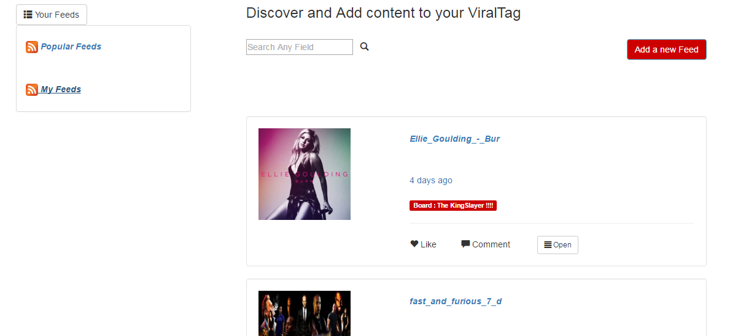

Click on the feed list to open the corresponding feeds.

*Users can switch the feeds just by clicking on the corresponding feed name on the top. *

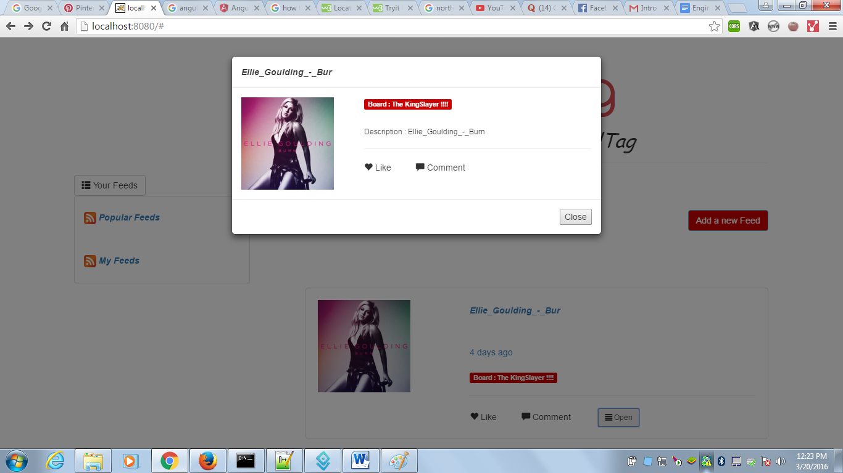

Clicking on the open display (in a dialog) additional feed details like description, date created etc.

*Additional thing :*

*I have used moment.js to show the time by which the following feed was published.*

*Also when you click on the image it takes you to the source url of the post.*

Hope you will like my work, thanks for the task.

# Regards

# ASG, Abhishek Sharma Gaur